NANHI PAHEL
"EARLY CHILDHOOD & EDUCATION”
CSR Initiative of Fusion Finance Limited

Report Timeline: Quarter 1 (April to June)
Location: Saharanpur, Uttar Pradesh & Roorkee, Uttarakhand
Implemented By: Asheerwad (India) Foundation

Executive Summary
This report presents the progress of the Nanhi Pahel “Early Childhood & Education” A CSR Initiative of Fusion and implemented by Asheerwad (India) Foundation. The center’s primary focus is to provide a safe, educational, and nurturing environment that supports early childhood development, health, and parental engagement.
Problem Statement: In the underserved communities of Roorkee and Saharanpur in Uttarakhand and Uttar Pradesh children face a critical lack of access to structured, and nurturing environments necessary for early childhood development. This gap is particularly burdensome for working parents especially women, who struggle to find reliable childcare, leading to compromised safety, inadequate environment, and missed opportunities for early learning among young children. Without intervention, these children are at risk of developmental delays, health issues, and social exclusion, perpetuating cycles of poverty and limited opportunity. The Nanhi Pahal initiative seeks to address these challenges by offering quality and early education that is inclusive, protective, and developmentally focused.
Center Name | Months | Target Beneficiaries | Total Strength | Boys | Girls | New Admissions  in Q1 | Passed out/ Dropouts in Q1 | %  Marginalized  Beneficiaries
Paniyala-Roorkee  (Uttarakhand) | April | 25-30 | 19 | 9 | 10 | 8 | 2 Dropouts | 100%
Paniyala-Roorkee  (Uttarakhand) | May | 25-30 | 28 | 12 | 16 | 9 | 2 Dropouts | 100%
Paniyala-Roorkee  (Uttarakhand) | June | 25-30 | Summer break | Summer break | _ | _ | 2 Dropouts | _
Number of Beneficiaries:

Center Name | Months | Target Beneficiaries | Total Strength | Boys | Girls | New Admissions  in Q1 | Passed out/ Dropouts in Q1 | %  Marginalized  Beneficiaries
Saharanpur-  (Uttar Pradesh) | April | 25-30 | 20 | 8 | 12 | 12 | 1-Passed out  1-Dropout | 100%
Saharanpur-  (Uttar Pradesh) | May | 25-30 | 27 | 12 | 15 | 7 | 1-Passed out  1-Dropout | 100%
Saharanpur-  (Uttar Pradesh) | June | 25-30 | Summer break | Summer break | _ | _ | 1-Passed out  1-Dropout | _

Team:

Admissions & Attendance
- Both centers welcomed new admissions this quarter alongside ongoing children from the previous session.
- Consistent attendance was observed, ensuring continued developmental support and engagement.

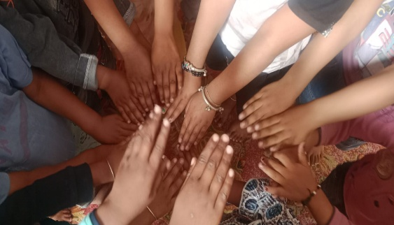
Child Development & Daily Activities
- Grooming and Hygiene: Regular combing, nail trimming, and tidy clothing were maintained to install hygiene habits.
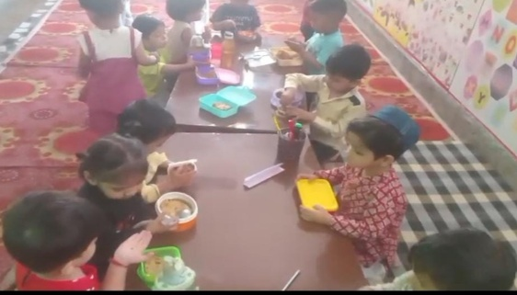
- Learning & Play-Based Activities: Children engaged in storytelling, shape and color recognition, crafting, and coloring to promote creativity, cognitive skills, and fine motor development.
- Nutrition:
  - Hygienic and nutritious snacks are provided daily.
  - Fresh fruits are served twice a week to promote healthy eating habits.

Teacher Training Workshop
- On 4th June 2026, a teacher training workshop was held at Shree Kabir Dharmarth Trust samiti, Devpura Rishikul Haridwar
- Trainers included:
Sr.No | Name | Designation
1 | Mr. Sujeet Pandey | Principal, (S.V.M.I.C. Doiwala Dehradun)
2 | Sivani | PGI-English (S.V.M.I.C. Doiwala Dehradun
3 | Dr. Ashok Kumar Tomar | (A.C.M.O) Haridwar

Key Focus Areas Covered:
- Effective lesson planning and efficient use of the whiteboard to improve classroom delivery.
- Understanding children's emotional and developmental needs through empathetic classroom management.
- Adopting child-cantered teaching practices to encourage active participation and learning.
- Maintaining classroom hygiene while using interactive learning techniques such as storytelling, group activities, and play-based methods to create an engaging learning environment.
The training session proved to be highly beneficial for all participating teachers and support staff. It strengthened their understanding of effective classroom practices and provided practical approaches that can be readily implemented in their daily teaching. Throughout the workshop, participants actively engaged in discussions, practical demonstrations, and experience-sharing sessions, making the learning process interactive and relevant to their classroom realities.
During the feedback session, teachers expressed that the training helped them gain new perspectives on lesson planning, classroom organization, child engagement, and positive communication with students. Many participants shared that the practical examples and interactive activities increased their confidence in handling classroom situations more effectively. Overall, the workshop was well received, with participants appreciating its practical nature and expressing their commitment to applying the learnings to create a more supportive, inclusive, and child-friendly learning environment.
Health Camp Initiatives
On May 20th, 2026 and 22nd May,2026 free health check-up camps were organized exclusively for children in both Saharanpur and Roorkee Nanhi Pahel Centres. The camp was led by qualified paediatricians to ensure the overall health and well-being of the children enrolled at the centres.
The health camp included thorough paediatric check-ups such as growth and development assessments, nutritional evaluation, dental check-ups, vision screening, and monitoring of common childhood health concerns. Doctors also provided vaccinations guidance and offered personalized advice to caregivers on proper diet, hygiene, and preventive healthcare for children
Centre Name | Date of Health Camp | Children in Centre | Children Attended | Medical Team | NGO Team | Teachers
Saharanpur | 20/5/26 | 25 | 23 | Dr.Ashok Kumar Tomar (Retire.A.C.O.M-Haridwar)  Dr.S.Pratap Singh (R.B.S.K-Govt) | Meenu Thakur  Jitendra(director) | Reetu,  Minakshi
Roorkee | 22/05/26 | 26 | 22 | Dr.Junaid Akhtar (Physician),  Anas (Pharmacist) | Meenu Thakur  Jitendra(director) | Sonia,  Alka

Key activities and services provided

Included routine check-ups to assess overall health, monitoring growth parameters such as weight, height, and BMI to identify malnutrition or stunted growth, basic dental check-ups and guidance for oral hygiene, ensuring parents are informed about vaccination schedules and their importance, educating families on hygiene practices, nutrition, and preventive healthcare, and providing recommendations for follow-up visits for children needing specialized medical attention or additional immunizations.
During the health camp, we distributed multivitamin supplements, fruit juices, and coconut water to the children.
These provisions aimed to enhance their nutritional intake and promote overall health.

- Health Screening Findings

S. No. | Centre Name | Child's Name | Health Screening Findings
1 | Saharanpur Centre | Akanksha | Healthy
2 | Saharanpur Centre | Shanvi | Iron deficiency
3 | Saharanpur Centre | Harsh | Anemic
4 | Saharanpur Centre | Tejas | Protein deficiency (Low protein levels)
5 | Saharanpur Centre | Seerat | Underweight, Anemic, and Iron deficiency
6 | Roorkee Centre | Kartik | Underweight and Protein deficiency
7 | Roorkee Centre | Ayaan | Underweight
8 | Roorkee Centre | Ahmed | Healthy
9 | Roorkee Centre | Raman | Healthy
10 | Roorkee Centre | Adiva | Fungal skin infection

- Health assessment and nutritional screening of enrolled children

Learning Assessment Summary of Enrolled Children
Learning assessments were conducted during the quarter to evaluate the academic progress of children in key learning areas. However, due to the transition of existing students to formal schools, the admission of new children at the Centres, and the summer break in June, learning assessments during the quarter were conducted for a limited number of children.
A comparatively lower performance was observed in the May assessment than in April. In Saharanpur, the April 2026 assessment covered 8 enrolled children, while the May 2026 assessment included 7 children. In Roorkee, 11 children were assessed during the quarter, as the majority of the children had been recently enrolled and no assessment was conducted for them in both the centres. In the upcoming quarter, the teaching team will focus on strengthening identified learning gaps through targeted interventions, regular assessments, and individualized support to enhance the children's overall academic progress.
Parent-Teacher Meetings (PTMs)
PTMs conducted at both centres on 25th April, and 30th May. These meetings aimed to discuss the overall development of the children, address parental concerns, and enhance parent-teacher collaboration. PTM, issues related to student progress and attendance were also addressed, and parents were encouraged to regularly send their children to the centers to ensure consistent learning and overall development.
Roorkee | Saharanpur | Key Discussion Points
25th April | 25th April | Introduction with parents, discussion on children's initial adjustment and daily routine
30th May | 30th May | Review of learning activities, hygiene practices, and communication between teachers and parents

Door-to-Door Awareness Campaign
- Roorkee Centre: Door-to-door awareness campaigns were conducted on 23 April, 2 May, and 22 June 2026 to promote the importance of early childhood education among parents and the local community.
- Saharanpur Centre: Door-to-door awareness campaigns were conducted on 7 April, 2 May, and 22 June 2026 by the teachers to raise awareness about the importance of early childhood education.
- Community Visits: Ms. Meenu Thakur (Coordinator) conducted door-to-door area visits at both centres on 2 June 2026 to interact with families, spread awareness about the Day Care Education Initiative, and encourage the enrolment of underprivileged children.
- The objective of the campaign was to encourage parents to enroll their children in the centers by informing them about the benefits of early learning in a structured, safe, and nurturing environment. During the visits, the team explained how the centers provide a convenient, hygienic, and educational setting that supports the overall development of young children.
- Special emphasis was given to how the centers ensure health, safety, and foundational learning, making them an ideal place for working parents to entrust their children. The campaign aimed to increase the admission rate and strengthen the connection between the centers and the local community.

Monthly Assessment Week
A Monthly Assessment Week has been implemented to evaluate each child's learning milestones, social behavior, and physical development. These assessment help in tailoring activities to individual child needs.
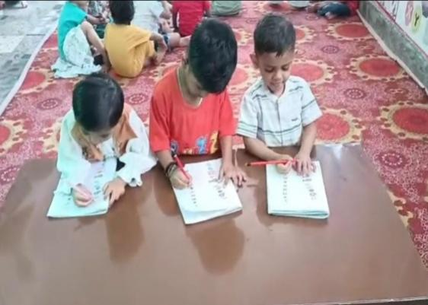
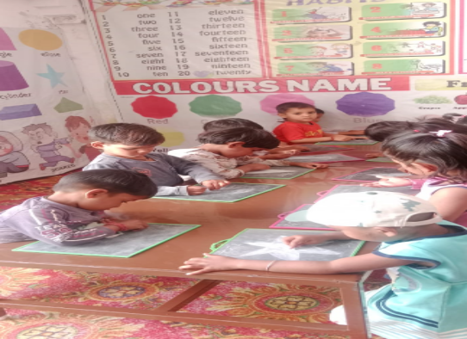


Saharanpur pic

Tree Plantation Drive – 5th June 2026
On the occasion of World Environment Day (5th June 2026), a Tree Plantation Drive was organized at both centers to promote environmental awareness and instill eco-friendly values among children and staff.
- Children, along with teachers and staff, actively participated in planting saplings in and around the center premises.
- The activity aimed to educate children about the importance of trees and caring for the environment.
- The event also helped in beautifying the surroundings and creating a greener learning space.
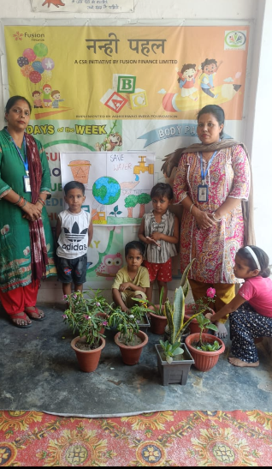
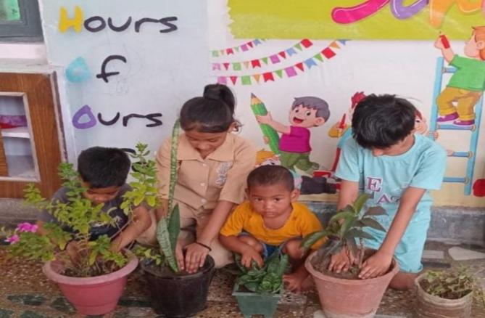

Roorkee
Saharanpur
Birthday Celebrations at Centres
Celebrating birthdays is an important part of creating a joyful, inclusive, and emotionally nurturing environment for children. Special care is taken to make each child's birthday memorable with decorations.

Summer Vacation Activities at Centres
During the summer vacation, a series of engaging and activity-based learning sessions were organized at the Saharanpur and Roorkee Centres to ensure children continued learning and holistic development. The vacation programme was carefully designed to provide a balance of education, creativity, and recreation through interactive and hands-on activities. These sessions encouraged learning through play, fostered creativity, enhanced social interaction, and supported the overall cognitive, emotional, and physical development of the children in a joyful and stimulating environment.
- Art & Craft Sessions
- Storytelling & Rhymes Time
- Coloring & Painting Activities

Conclusion
During this quarter, both the Saharanpur and Roorkee Centres continued to provide a supportive and engaging learning environment through a range of educational, creative, and awareness-building activities. Key initiatives included teacher training workshops, summer vacation engagement programs, birthday celebrations, interactions with parents and teachers etc. The quarter emphasized the holistic development of children by fostering their academic, social, emotional, and personal growth. Overall, the Centres remained committed to creating a safe, nurturing, and inclusive space that supports the well-being and development of every child.

******** Thank You***********

